Operating System
Lab#07

NEHA-E-NOOR
FA17-BECE-0007

Task1:
Orphan Process

#include<stdio.h>
#include <sys/types.h>
#include <unistd.h>

int main()
{

int pid = fork();

if (pid > 0)
printf("Parent is in process.!");

else if (pid == 0)
{
sleep(30);
printf("Child is in process.!");
}

return 0;
}

Output:

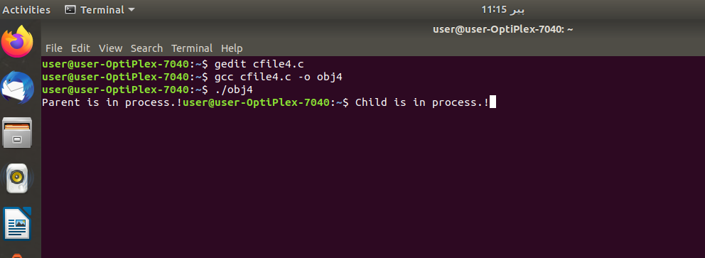

Task2:
Zombie Process
#include<stdio.h>
#include <sys/types.h>
#include <unistd.h>
int main()
{
int id;
id=fork();

if(id>0)
{
printf("Parent will sleep \n");
sleep(5);
}
if(id==0)
printf("I am child \n");
return 0;
}

Output:
